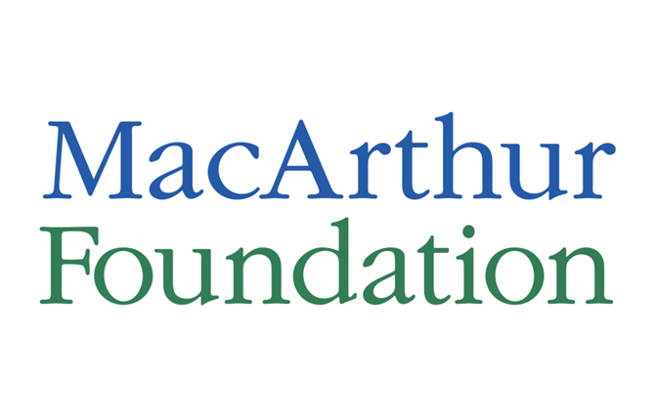
Arts & Culture Loan Fund: Application
Please provide the following information:
- Name:
- Title:
- Organization Legal Name:
- Phone Number:
- E-mail:
Please answer the following questions
What are the biggest challenges currently facing your organization in managing its finances?

What are 1 – 2 changes (big or small) that you would like to see occur in your organization’s financial management and in the next few years

Does your organization currently have a line of credit or working capital loan? If so, who is the lender?

Is your organization going through any significant leadership transitions or organizational changes? If yes, please describe.

Indicate your interest in the following (check all that apply):
- Working capital loan
- Financial management training series (4 sessions taking place between April and June 2019)
- One-on-one technical assistance (check all that apply)
    - Fiscal systems redesign
    - Budget / cash flow projections
    - Technology implementation
    - Process redesign
    - Strategic planning
    - Board training

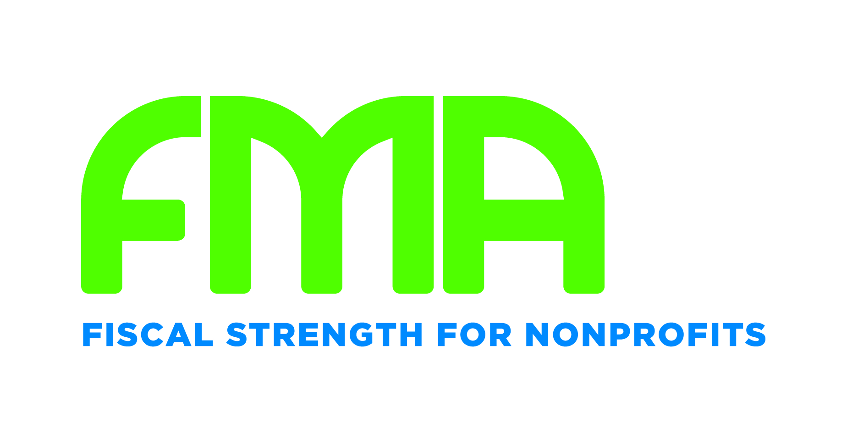
Please complete, scan and send this form to loanfund@fmaonline.net. FMA will follow up to confirm next steps.

